ASSESSMENT -1
MARKS OBTAINED
TOTAL MARKS:50
NAME :______________________________
CLASS : UKG _____
DATE : _____________
SUBJECT : ENVIROMENTAL STUDIES

I. CIRCLE THE SENSE ORGANS WHICH MATCHES WITH GIVEN PICTURE:(5X1=5)

A

B

C

D

E

II. WRITE THE FIRST LETTER OF THE PLANTS PART: (4X1=4)

III. MATCH THE COMMUNITY HELPERS WITH THEIR PROPERTY: (5X1=5)
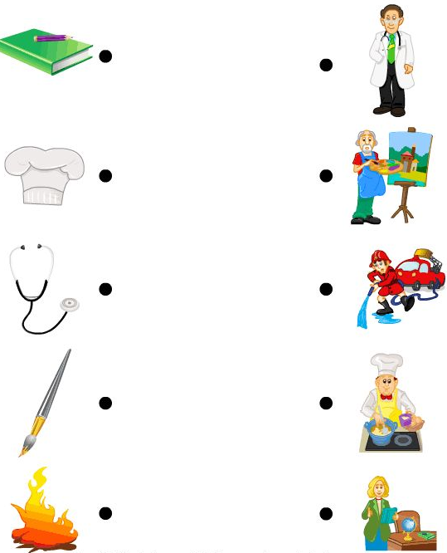

A

B

C

D

E

IV. MATCH MAJOR BODY PARTS: (5X1=5)

v. WRITE THE MISSING LETTERS: (4X1=4)
1. H___ ___ D
2. N___S___
3.EY___S
4. M___UT___

VI. DRAW A FLAG AND COLOUR IT : (4X1=4)

VII. DRAW NATIONAL CURRENCY “RUPEE” : ( 3X1=3)

VIII. ORAL (20)

*********** ALL THE BEST ************

